 | TEMASEK JUNIOR COLLEGE  2026 JC2 PRELIMINARY EXAMINATION  Higher 1 | 

H1 GEOGRAPHY | 8834/01
Paper 1  INSERT | 31 August 2026
 | 3 hours

READ THESE INSTRUCTIONS FIRST

This Insert contains all the Resources referred to in the questions.

This document consists of 11 printed pages, and 1 blank page.

Resource 1 for Question 1

Base map of Toa Payoh and its surrounding area

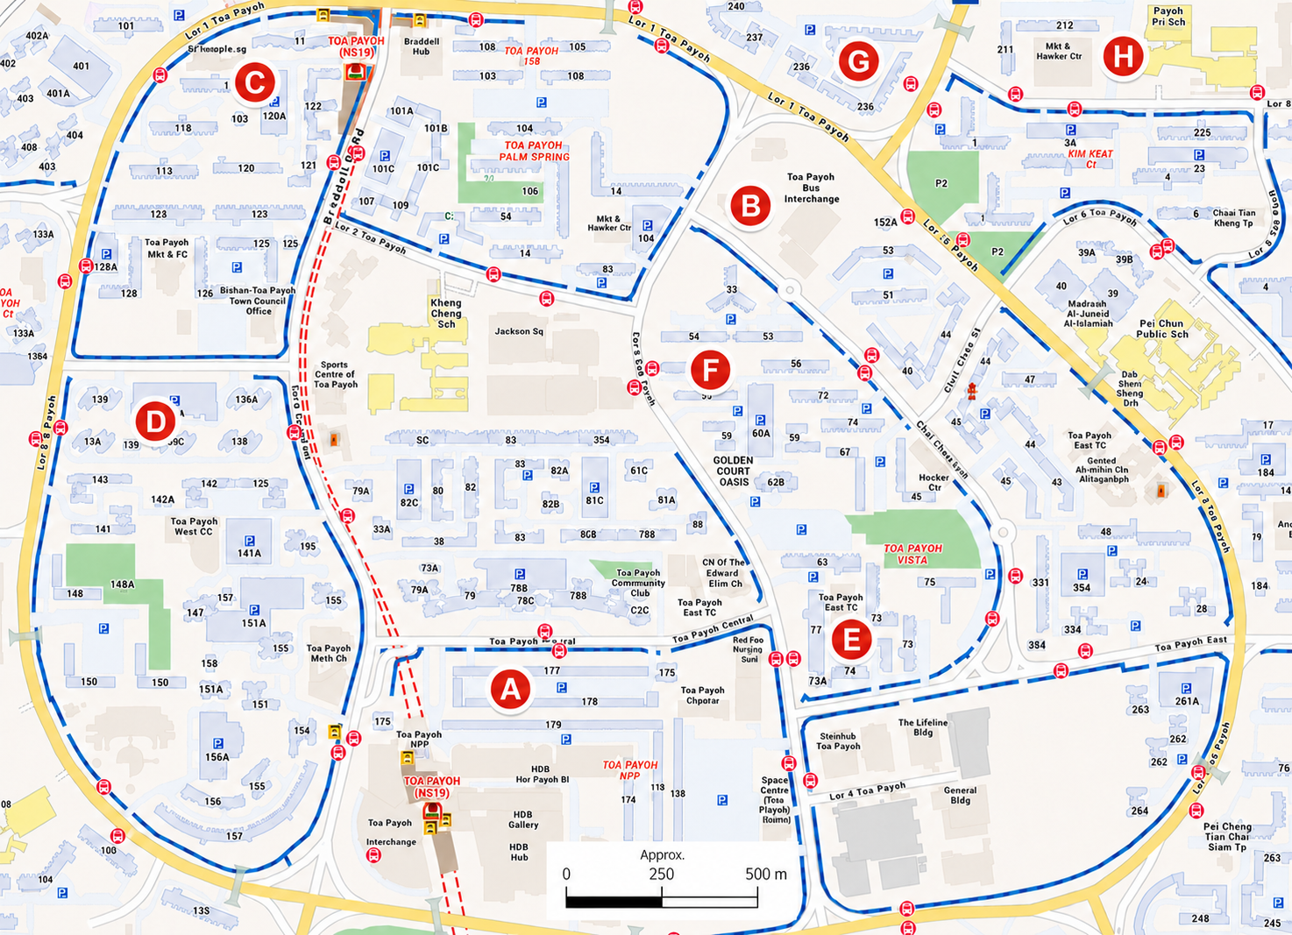
Resource 2A for Question 1

Visible contents in the top layer of a blue recycling bin during the waste audit

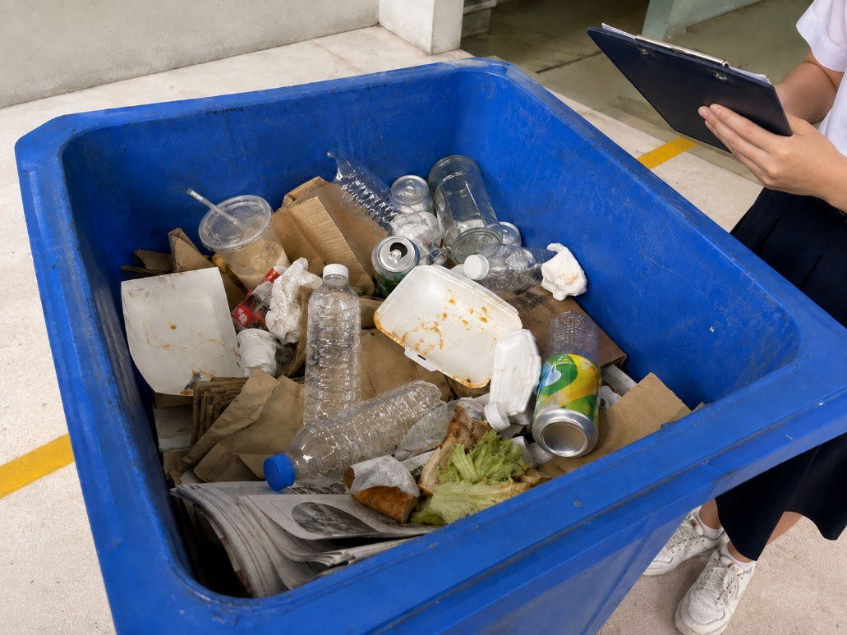

Resource 2B for Question 1

Students conducting survey

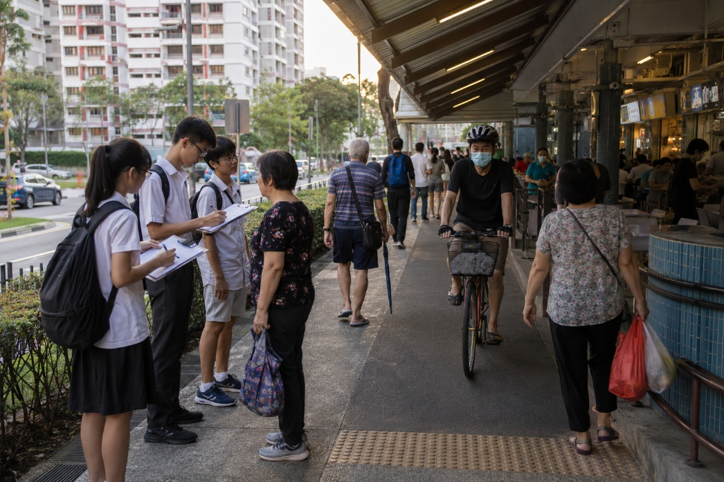

Resource 3 for Question 1
Survey Questionnaire

We are Geography students investigating recycling practices in Toa Payoh. The survey is anonymous and will take about two minutes. Participation is voluntary. Thank you!

Q1. How often does your household use a blue recycling bin or recycling chute?
- Regularly
- Occasionally
- Rarely
- Never
Q2. What is the main factor that makes it difficult for your household to recycle correctly? Select one answer.
- Need to rinse or clean containers
- Unsure which items can be recycled
- Recycling bin is inconveniently located
- Limited space to store recyclables at home
- Do not think household recycling makes much difference
- Other: __________

Q3. Which items can be placed in a blue recycling bin or chute? Select all that apply.
Clean paper/  cardboard | Rinsed plastic bottle | Glass bottle | Metal can | Food scraps | Soiled container | E-waste | Styrofoam
□ | □ | □ | □ | □ | □ | □ | □

Q4. Approximately how long does it take to walk from your home to the nearest blue recycling bin or chute?
- Less than 2 minutes
- 2-5 minutes
- More than 5 minutes
- I do not know

Q5. ‘The nearest recycling facility is easy to see and reach.’
- 1. Strongly agree
- 2. Agree
- 3. Neutral
- 5. Disagree
- 6. Strongly disagree

Q6. Briefly explain one change that would encourage your household to recycle more correctly.

Resource 4A for Question 1

Results of the visual waste audit

Site | Location / dominant land use | Correct recyclables  (out of 20) | Contamination (out of 20)
A | Toa Payoh Central / commercial | 11 | 9
B | Bus interchange-MRT / transport | 12 | 8
C | Lorong 1 / residential | 15 | 5
D | Lorong 2 / residential | 17 | 3
E | Lorong 4 / market-food | 9 | 11
F | Lorong 5 / residential | 13 | 7
G | Lorong 7 / residential | 16 | 4
H | Lorong 8 / market-food | 8 | 12

Resource 4B for Question 1

Selected survey questionnaire results (80 residents)

Questionnaire result | Number of respondents
Use a blue recycling facility regularly | 31
Use it occasionally | 29
Use it rarely or never | 20
Main barrier: need to rinse/clean containers | 24
Main barrier: unsure what can be recycled | 21
Main barrier: recycling facility inconveniently located | 17
Other main barriers | 18
Correctly identified all four accepted material groups and rejected all contaminants | 46
Reported a walk of more than 5 minutes or did not know the nearest facility | 25
Agreed/strongly agreed that the nearest facility is easy to see and reach | 49

Resource 5 for Question 2

Share of the urban population living in slums, 2024
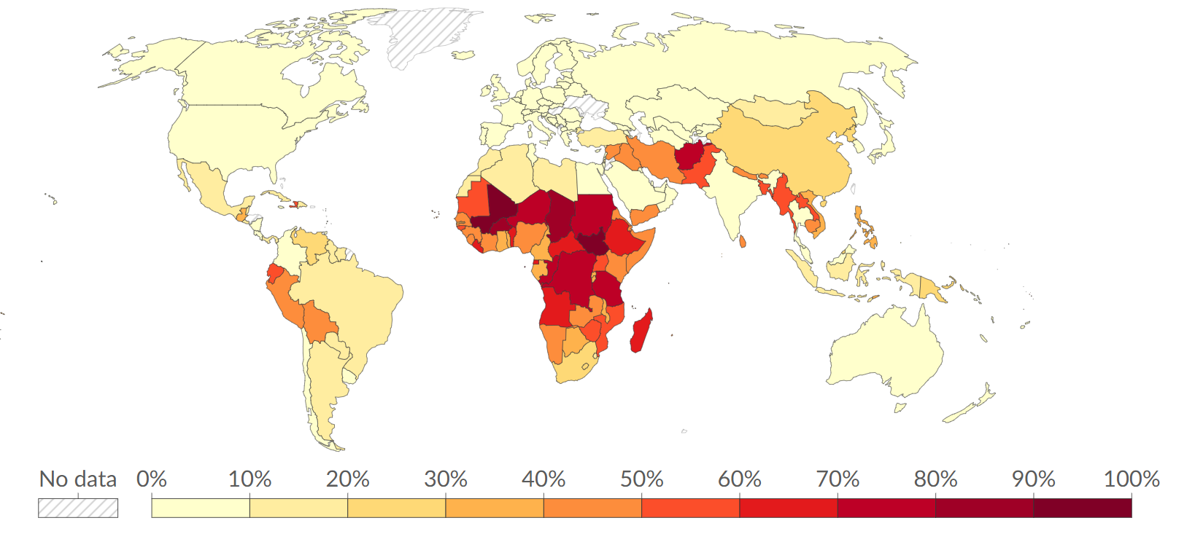
Resource 6 for Question 2

Cartoon showing the impact of urban reimaging

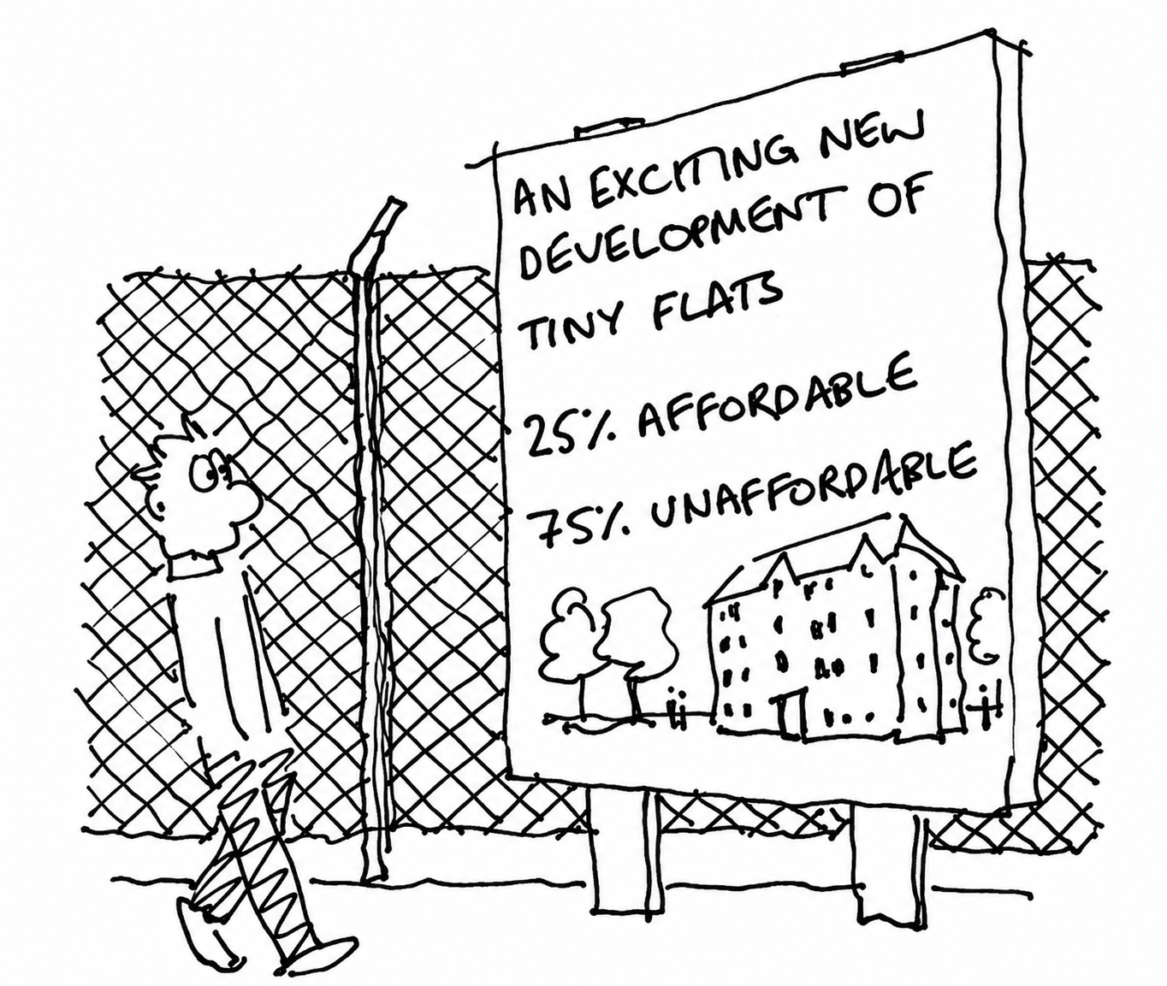

Resource 7 for Question 2

Dundee docklands in Scotland

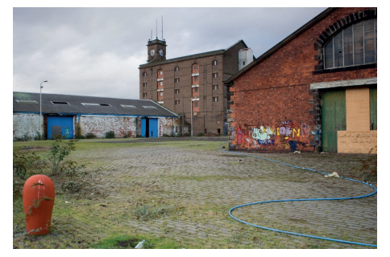
2006 – Derelict warehouses

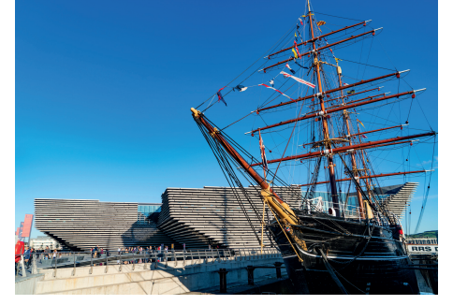
2018 – Victoria & Albert Museum and Royal Research Ship Discovery

Resource 8 for Question 3

Atmospheric carbon dioxide concentration over the past 800 000 years

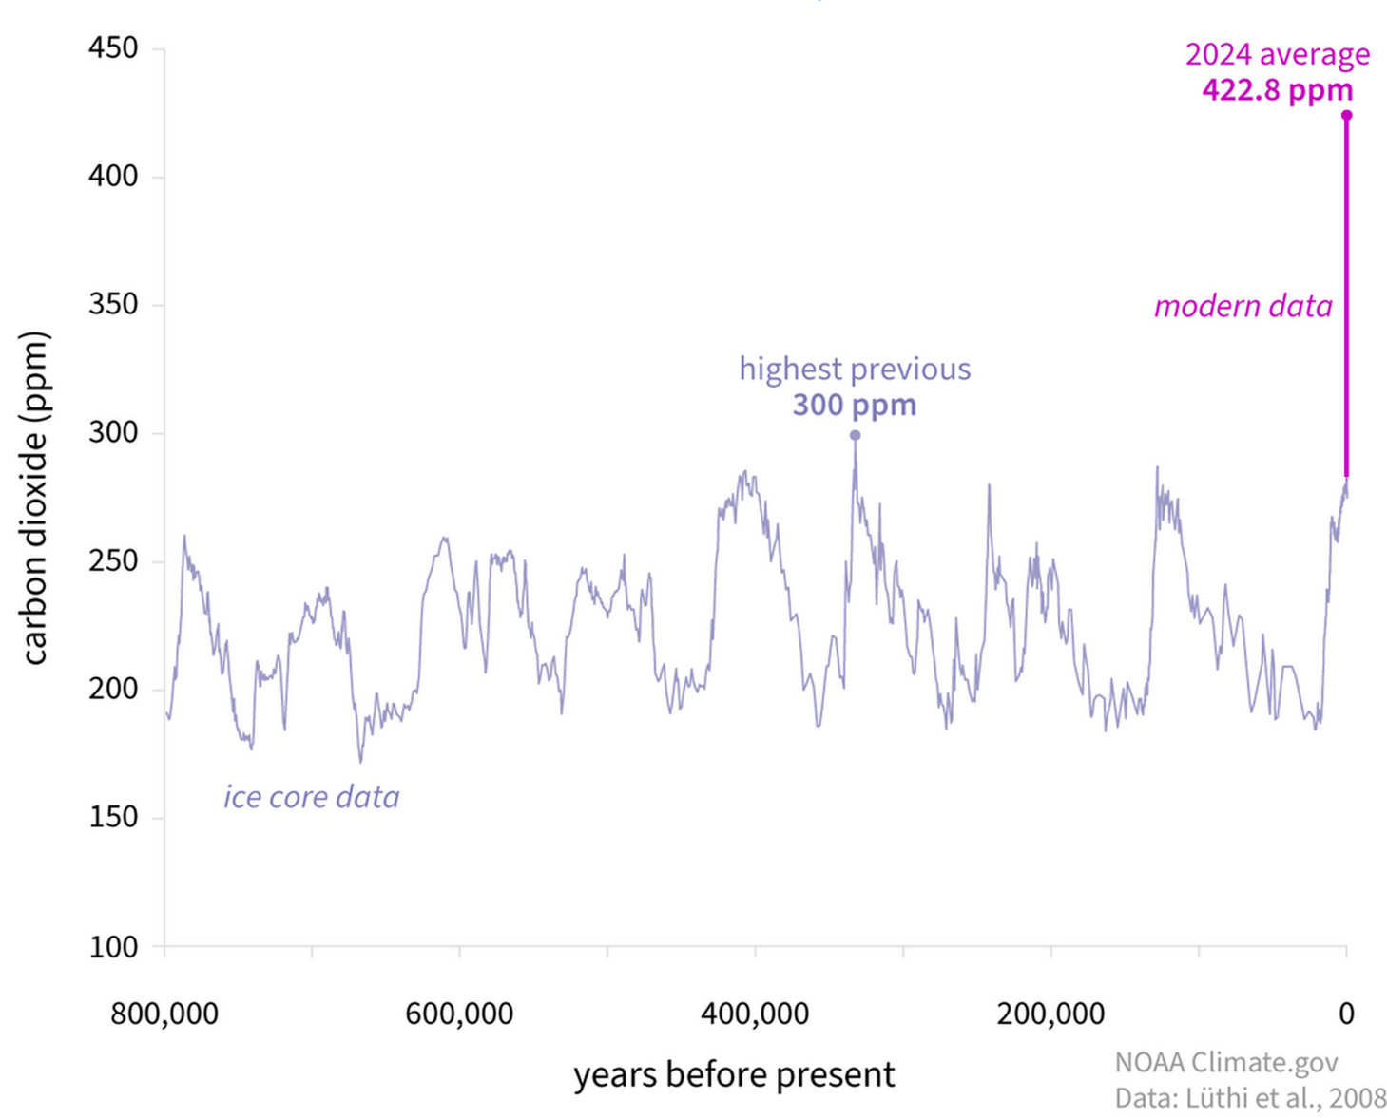

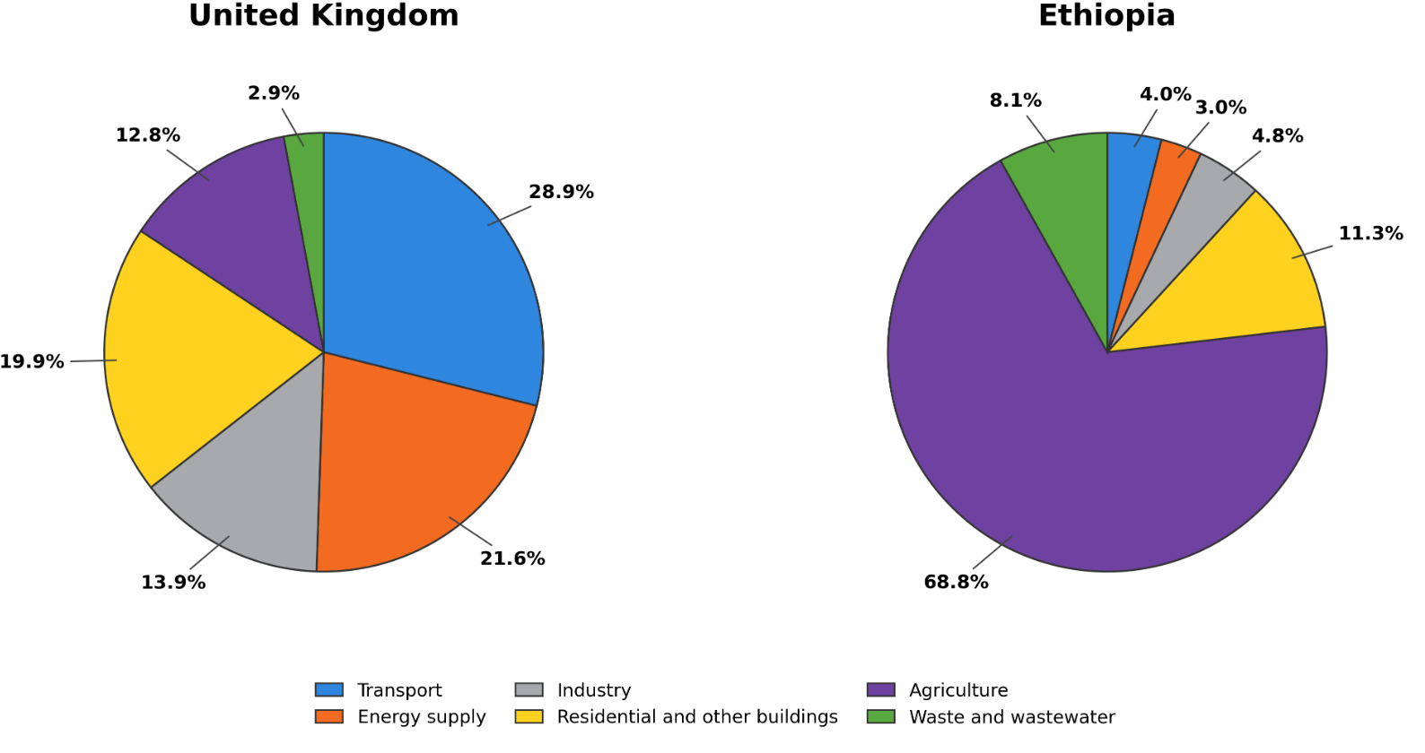

Resource 9 for Question 3

Sources of greenhouse gas emissions
in the United Kingdom (UK) and Ethiopia in 2023

Resource 10 for Question 3

The predicted changing extent of permafrost
in northern Eurasia and North America

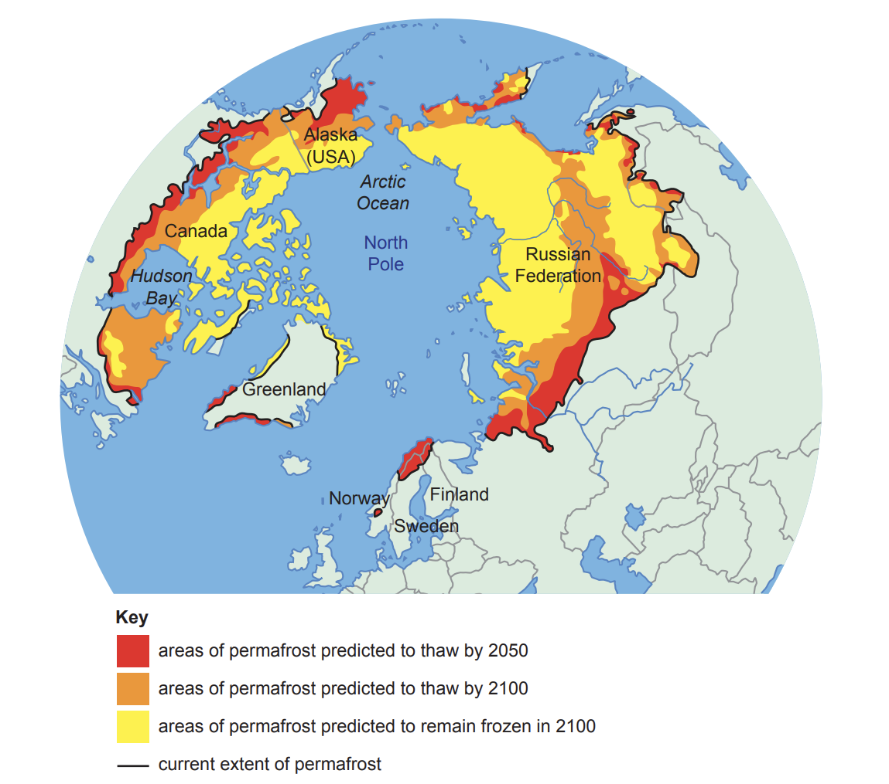

BLANK PAGE

